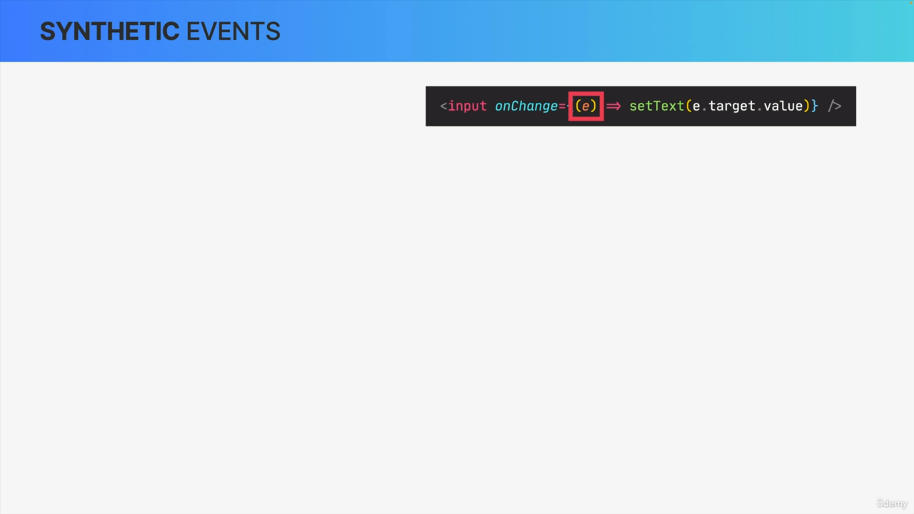

Whenever we declare an event handler like this one, React gives us access to the event object that was created, just like in vanilla JavaScript.

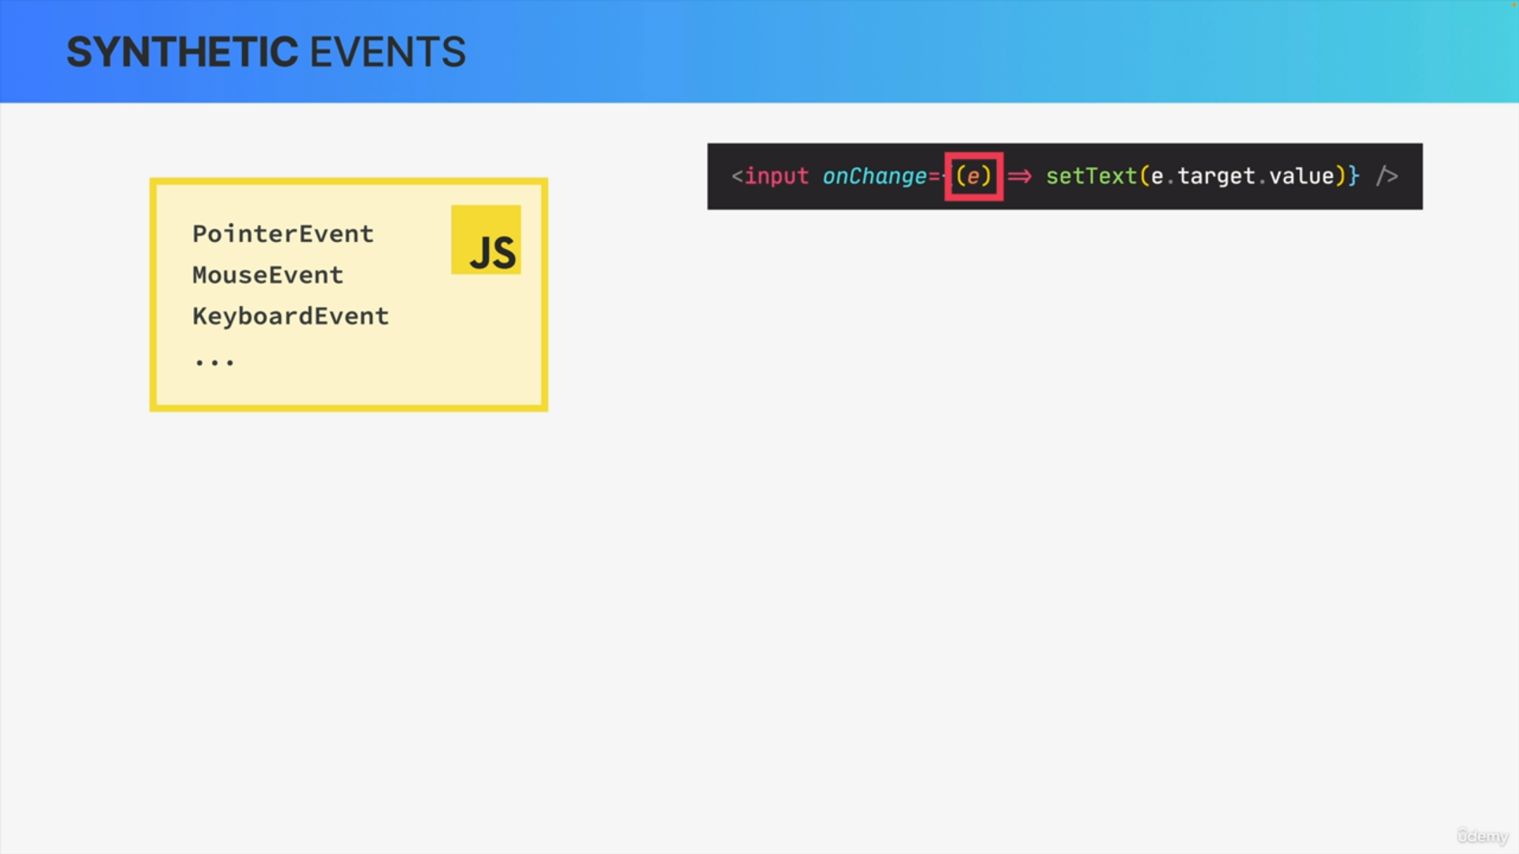

However, in React, this event object is actually different. So, in vanilla JavaScript, we simply get access to the native DOM event object, for example, pointer event, mouse event, keyboard event, and many others. React, on the other hand, will give us something called a synthetic event which is basically a thin wrapper around the DOM'S native event object.

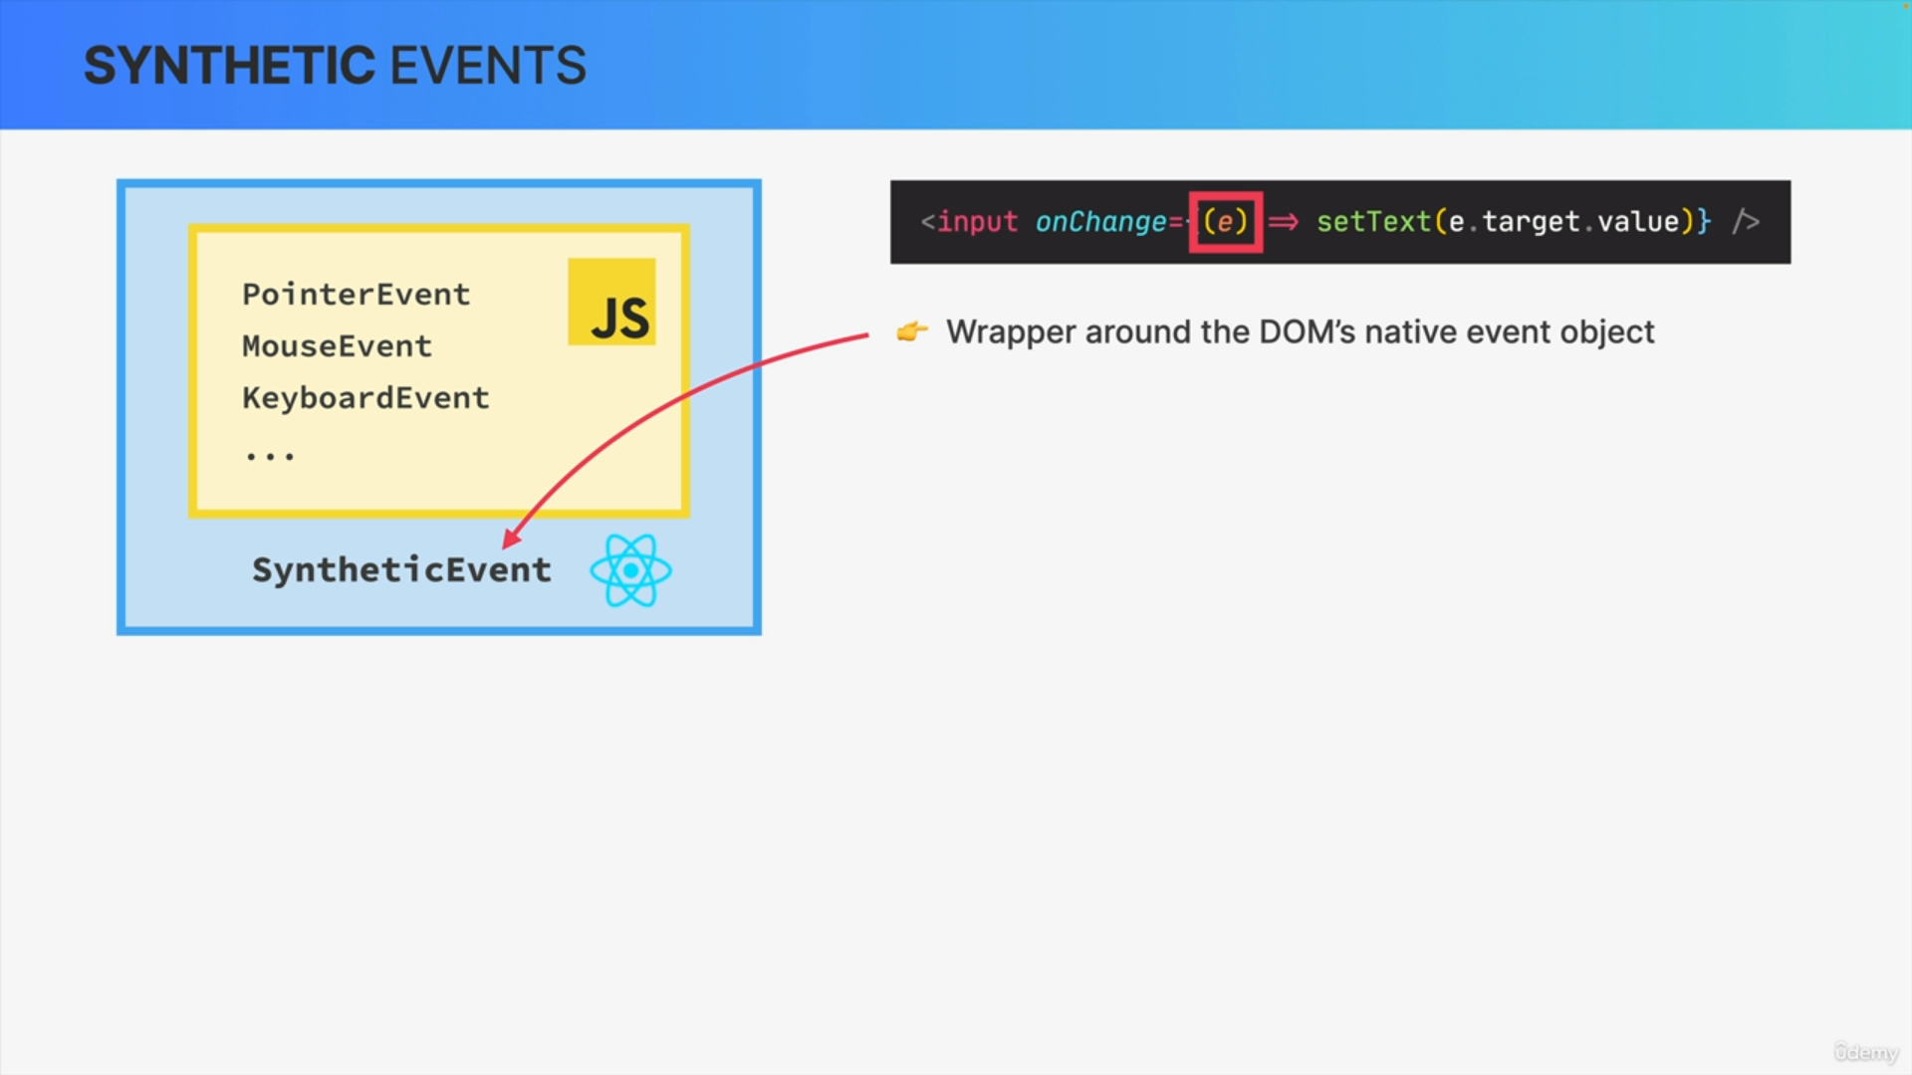

By wrapper we simply mean that synthetic events are pretty similar to native event objects, but they just add or change some functionalities on top of them.

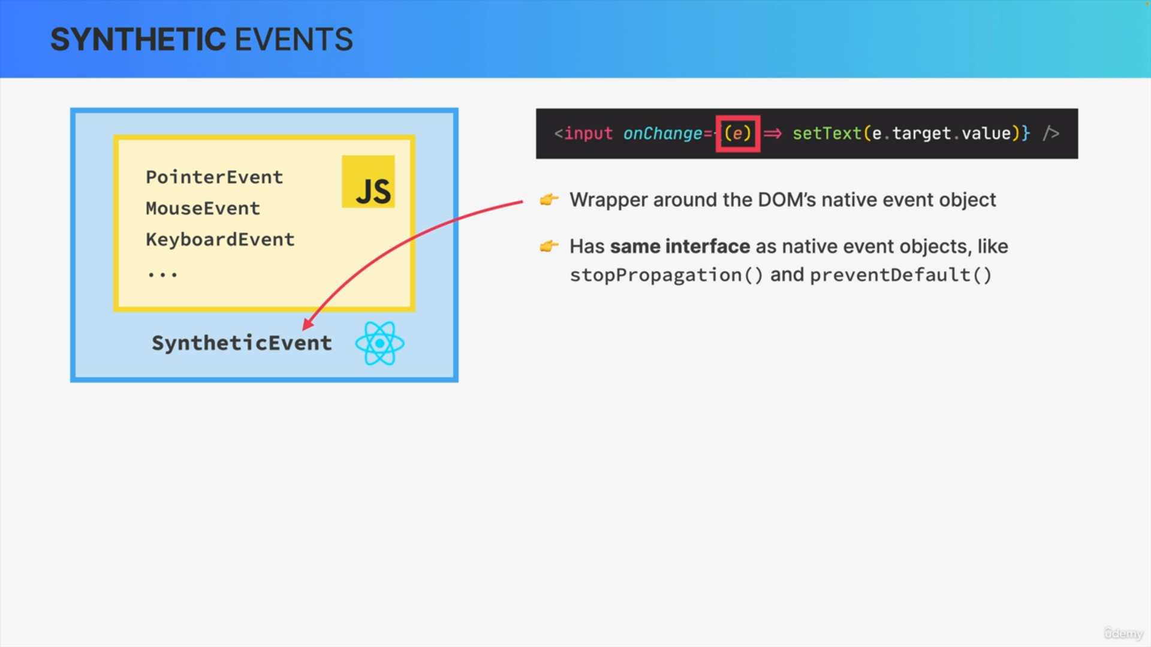

So, these synthetic events have the same interface as native event objects and that includes the important methods stopPropagation and preventDefault.

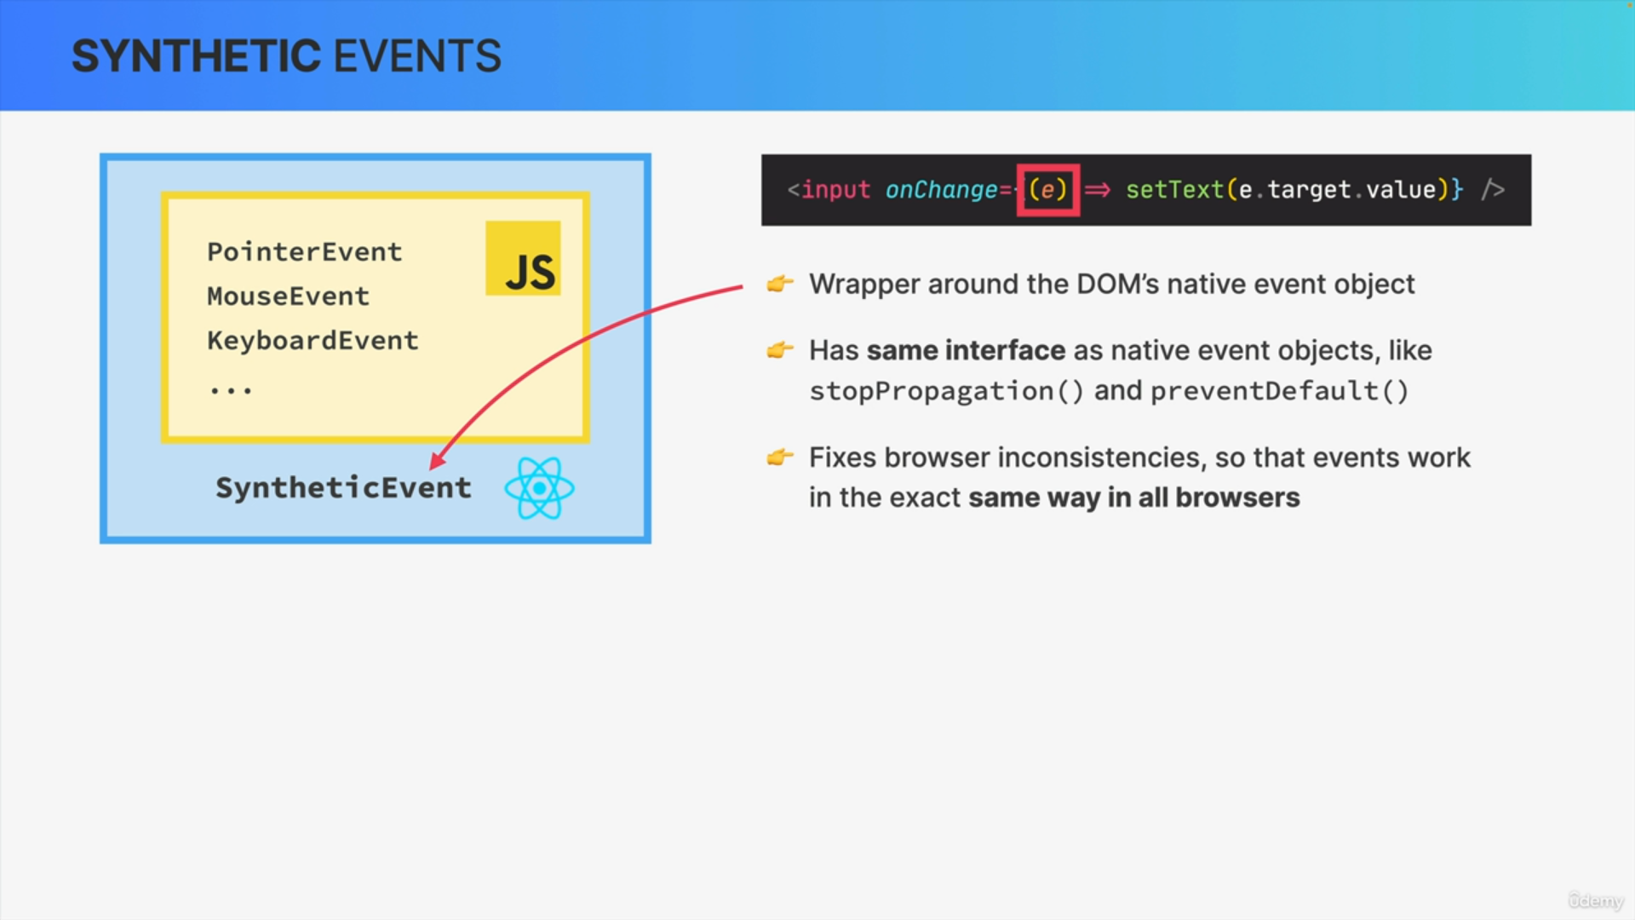

What's special about synthetic events though and one of the reasons why the React team decided to implement them is the fact that they fix some browser inconsistencies making it so that events work in the exact same way in all browsers.

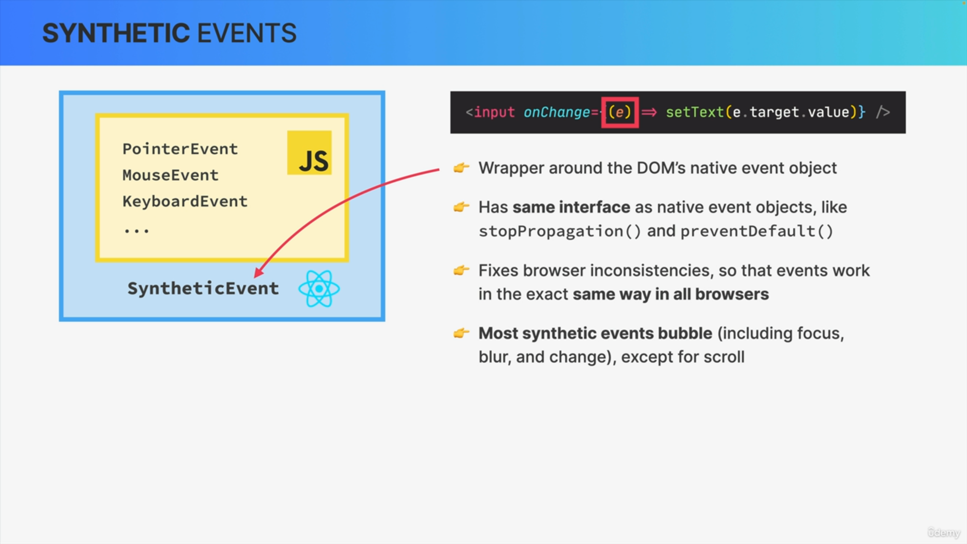

The React team also decided that all of the most important synthetic events actually bubble, including the focus, blur, and change events which usually do not bubble. The only exception here is the scroll event which does also not bubble in React.

